Important signals scope measurements

Date: 21 December 2016

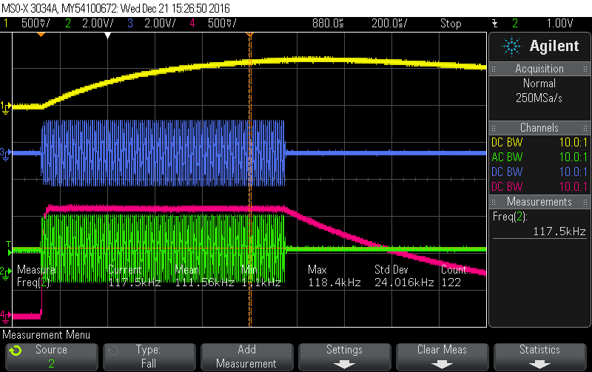

Measurement done with battery low status
Yellow: half-sine-rect, measured between R140 and R141
Blue: BATSENSE1 measured on anode D38
Pink: cathode D38
Frequency of sine wave is 118 kHz (as can be seen)

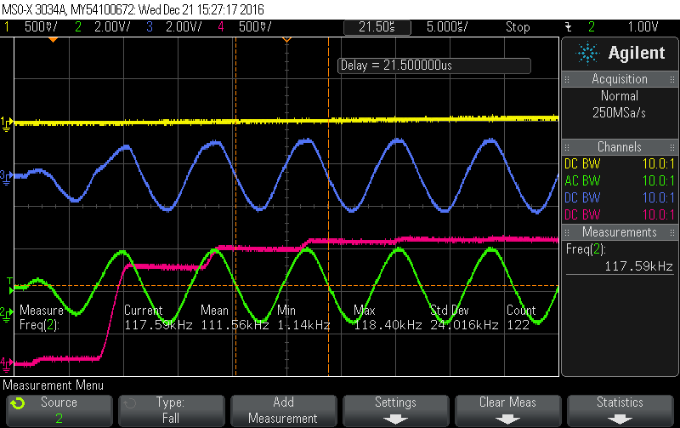

Same as previous, but now during startup

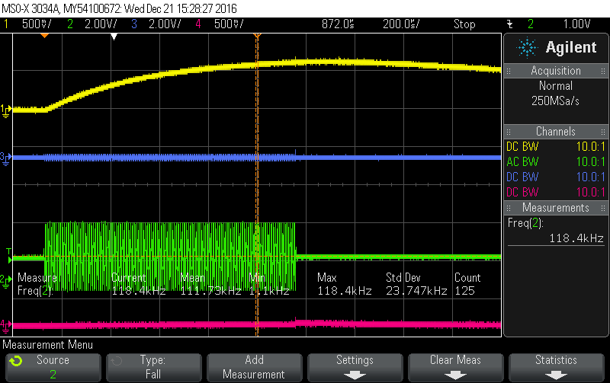

Same as first, but now with battery voltage OK

