Hardware Test Results me-zkl3000-switch-board

Based on schematics: 2017-01-27 me-zklmain-board.pdf

Power Supply Unit +12V
Prerequisites: Connect 12V power supply to +VBAT
Test ID | HT-01
Test procedure | Check +VBAT for +12V
Expected result | 12V
Measured | Voltage at Main Board = +12.02 V  Voltage at Switch Board = +11.75 V

Test ID | HT-02
Test procedure | Check +3V3 regulator output with respect to +VBAT (12V)
Expected result | Output at 3.3V
Measured | Output at +3.298 V

Test ID | HT-03
Test procedure | Check +5V regulator output with respect to +VBAT (12V)
Expected result | Output at +5V
Measured | Output at +4.997

Test ID | HT-04
Test procedure | Check +3V3-MCU with +VBAT at 12V  - Make MCU-SUPPLY-EN high  - Make MCU-SUPPLY-EN low
Expected result | - Output = +3.3V by default and when MCU-SUPPLY-EN is high  - Output = 0V when MCU-SUPPLY-EN is low
Measured | - Output = +3.294 by default and when MCU-SUPPLY-EN is high  - Output = +0.924 V when MCU-SUPPLY-EN is low
Comments | A pull down at +3V3-MCU will enable the line to go completely to zero

Power Supply Unit +6.4V
Prerequisites: Connect 6.4V power supply to +VBAT
Test ID | HT-05
Test procedure | Check +VBAT for +6.4V
Expected result | 6.4V
Measured | Input Voltage at Main Board = 6.45 V  Voltage at Switch Board = 6.15 V

Test ID | HT-06
Test procedure | Check +3V3 regulator output with respect to +VBAT (6.4V)
Expected result | Output at 3.3V
Measured | Output at +3.298 V

Test ID | HT-07
Test procedure | Check +5V regulator output with respect to +VBAT (6.4V)
Expected result | Output at +5V
Measured | Output at +4.996 V

Test ID | HT-08
Test procedure | Check +3V3-MCU with +VBAT at 6.4V  - Make MCU-SUPPLY-EN high  - Make MCU-SUPPLY-EN low
Expected result | - + Output = +3.3V by default and when MCU-SUPPLY-EN is high  - Output = 0V when MCU-SUPPLY-EN is low
Measured | - Output = +3.295 by default and when MCU-SUPPLY-EN is high  - Output = +0.926 V when MCU-SUPPLY-EN is low
Comments | A pull down at +3V3-MCU will enable the line to go completely to zero

Sine Wave Generator
Prerequisites: EN-SINEGEN is high, +5V Power Supply is active
Test ID | HT-09
Test procedure | Check sine wave generator
Expected result | Sine wave of 118KHz with Vpp of 4V at output of U9B  (green signal in the picture below)  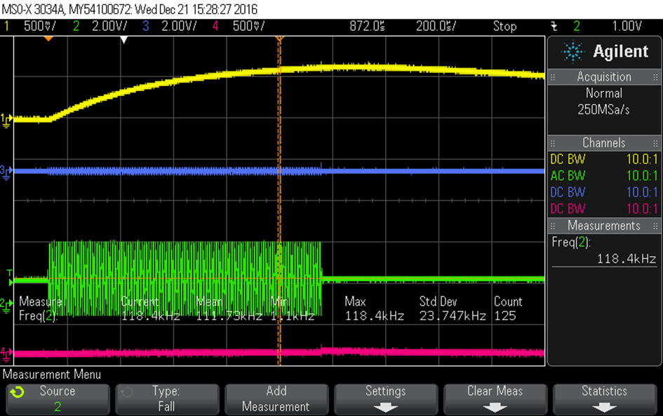
Measured | Sine wave of 116KHz with Vpp of about 4V at output of U9B  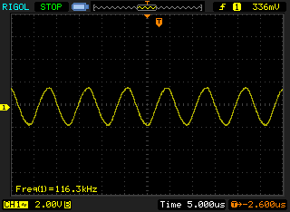

Test ID | HT-10
Test procedure | Check comparator threshold signal
Expected result | A smoothed out rectified wave of about 600mV at C14 (Yellow signal in picture below)
Measured | A smoothed out rectified wave of about 650mV at C14  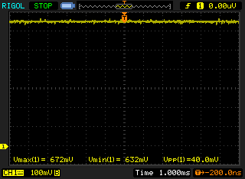

Control Microcontroller
Prerequisites: +3V3 Power Supply is active
Test ID | HT-11
Test procedure | Connect programming cable  Program device
Expected result | OK
Measured | OK

Test ID | HT-12
Test procedure | Check debug UART
Expected result | should be printing UART characters on PC terminal
Measured | Printing and Receiving UART characters through PC terminal

Test ID | HT-13
Test procedure | Check versioning  - Read VER0-VER3
Expected result | Should read 1,0,0,0
Measured | VER0 – VER3 = 1,0,0,0

Test ID | HT-14
Test procedure | Check CAN  - Transmit message at 500 KHz bit rate  - Receive message at Measurement and Drive Microcontroller  - Transmit message from Measurement and Drive Microcontroller  - Receive message at Control Microcontroller
Expected result | Transmitted and received message should be equal
Measured | Transmit and Receive messages are equal

Measurement Microcontroller
Prerequisites: +3V3-MCU Power Supply is active
Test ID | HT-15
Test procedure | Connect programming cable  Program device
Expected result | OK
Measured | OK

Test ID | HT-16
Test procedure | Check debug UART
Expected result | should be printing UART characters on PC terminal
Measured | Printing and Receiving UART characters through PC terminal

Test ID | HT-17
Test procedure | Check versioning  - Read VER0-VER3
Expected result | Should read 1,0,0,0
Measured | VER0 – VER3 = 1,0,0,0

Test ID | HT-18
Test procedure | Check CAN  - Transmit message at 500 KHz bit rate  - Receive message at Control and Drive Microcontroller  - Transmit message from Control and Drive Microcontroller  - Receive message at Measurement Microcontroller
Expected result | Transmitted and received message should be equal
Measured | Transmit and Receive messages are equal

Drive Microcontroller
Prerequisites: +3V3-MCU Power Supply is active
Test ID | HT-19
Test procedure | Connect programming cable  Program device
Expected result | OK
Measured | OK

Test ID | HT-20
Test procedure | Check debug UART
Expected result | should be printing UART characters on PC terminal
Measured | Printing and Receiving UART characters through PC terminal

Test ID | HT-21
Test procedure | Check versioning  - Read VER0-VER3
Expected result | Should read 1,0,0,0
Measured | VER0 – VER3 = 1,0,0,0

Test ID | HT-22
Test procedure | Check CAN  - Transmit message at 500 KHz bit rate  - Receive message at Control and Measurement Microcontroller  - Transmit message from Control and Measurement Microcontroller  - Receive message at Drive Microcontroller
Expected result | Transmitted and received message should be equal
Measured | Transmit and Receive messages are equal

Single Switch Section-1
Prerequisites: All power supplies are active, Battery Board or suitable supply is connected
Test ID | HT-23
Test procedure | Check Switch Section 1 ON Function  - Ensure PWM input of minimum 2kHz with 50% duty cycle at R79 (SECTION1-ON)  - Ensure DC voltage at R81 (SECTION1-OFF)
Expected result | Signal at R70 should be high (RDS-LOW-1)
Measured | RDS-LOW-1 is logic high

Test ID | HT-24
Test procedure | Check Switch Section 1 OFF Function  - Ensure PWM input of minimum 2kHz with 50% duty cycle at R81 (SECTION1-OFF)  - Ensure DC voltage at R79 (SECTION1-ON)
Expected result | Signal at R70 should be low (RDS-LOW-1)
Measured | RDS-LOW-1 is logic low

Test ID | HT-25
Test procedure | Check Switch Section 1 Battery High Function  - Ensure voltage above +7V across J10 connector
Expected result | Signal at R76 should be high (BAT-LOW-1)
Measured | BAT-LOW-1 is logic high

Test ID | HT-26
Test procedure | Check Switch Section 1 Battery Low Function  - Ensure voltage below +6.5V across J10 connector
Expected result | Signal at R76 should be low (BAT-LOW-1)
Measured | BAT-LOW-1 is logic low

Single Switch Section-2
Prerequisites: All power supplies are active, Battery Board or suitable supply is connected
Test ID | HT-27
Test procedure | Check Switch Section 2 ON Function  - Ensure PWM input of minimum 2kHz with 50% duty cycle at R96 (SECTION2-ON)  - Ensure DC voltage at R98 (SECTION2-OFF)
Expected result | Signal at R87 should be high (RDS-LOW-2)
Measured | RDS-LOW-2 is logic high

Test ID | HT-28
Test procedure | Check Switch Section 2 OFF Function  - Ensure PWM input of minimum 2kHz with 50% duty cycle at R98 (SECTION2-OFF)  - Ensure DC voltage at R96 (SECTION2-ON)
Expected result | Signal at R87 should be low (RDS-LOW-2)
Measured | RDS-LOW-2 is logic low

Test ID | HT-29
Test procedure | Check Switch Section 2 Battery High Function  - Ensure voltage above +7V across J11 connector
Expected result | Signal at R93 should be high (BAT-LOW-2)
Measured | BAT-LOW-2 is logic high

Test ID | HT-30
Test procedure | Check Switch Section 2 Battery Low Function  - Ensure voltage below +6.5V across J11 connector
Expected result | Signal at R93 should be low (BAT-LOW-2)
Measured | BAT-LOW-2 is logic low

Single Switch Section-3
Prerequisites: All power supplies are active, Battery Board or suitable supply is connected
Test ID | HT-31
Test procedure | Check Switch Section 3 ON Function  - Ensure PWM input of minimum 2kHz with 50% duty cycle at R133 (SECTION3-ON)  - Ensure DC voltage at R135 (SECTION3-OFF)
Expected result | Signal at R124 should be high (RDS-LOW-3)
Measured | RDS-LOW-3 is logic high

Test ID | HT-32
Test procedure | Check Switch Section 3 OFF Function  - Ensure PWM input of minimum 2kHz with 50% duty cycle at R135 (SECTION1-OFF)  - Ensure DC voltage at R133 (SECTION1-ON)
Expected result | Signal at R124 should be low (RDS-LOW-3)
Measured | RDS-LOW-3 is logic low

Test ID | HT-33
Test procedure | Check Switch Section 3 Battery High Function  - Ensure voltage above +7V across J14 connector
Expected result | Signal at R130 should be high (BAT-LOW-3)
Measured | BAT-LOW-3 is logic high

Test ID | HT-34
Test procedure | Check Switch Section 2 Battery Low Function  - Ensure voltage below +6.5V across J14 connector
Expected result | Signal at R130 should be low (BAT-LOW-3)
Measured | BAT-LOW-3 is logic high

Single Switch Section-4
Prerequisites: All power supplies are active, Battery Board or suitable supply is connected
Test ID | HT-35
Test procedure | Check Switch Section 4 ON Function  - Ensure PWM input of minimum 2kHz with 50% duty cycle at R150 (SECTION4-ON)  - Ensure DC voltage at R152 (SECTION4-OFF)
Expected result | Signal at R141 should be high (RDS-LOW-4)
Measured | RDS-LOW-4 is logic high
Comments | SECTION4-ON and SECTION4-OFF signals are reversed at the top level sheet. This needs to be changed

Test ID | HT-36
Test procedure | Check Switch Section 4 OFF Function  - Ensure PWM input of minimum 2kHz with 50% duty cycle at R152 (SECTION4-OFF)  - Ensure DC voltage at R150 (SECTION4-ON)
Expected result | Signal at R141 should be low (RDS-LOW-4)
Measured | RDS-LOW-4 is logic low
Comments | SECTION4-ON and SECTION4-OFF signals are reversed at the top level sheet. This needs to be changed

Test ID | HT-37
Test procedure | Check Switch Section 4 Battery Low Function  - Ensure voltage below +6.5V across J15 connector
Expected result | Signal at R147 should be low (BAT-LOW-4)
Measured | BAT-LOW-4 is logic high

Test ID | HT-38
Test procedure | Check Switch Section 4 Battery Low Function  - Ensure voltage below +6.5V across J14 connector
Expected result | Signal at R147 should be low (BAT-LOW-4)
Measured | BAT-LOW-4 is logic low

Connectors

Test ID | HT-39
Test procedure | Check Detection LED  - Connect Detection led to J1-5  - Pull led individually high or low
Expected result | Led should turn on and off
Measured | LED turning on and off according to the input given. ESD protection circuit is missing here. This needs to be added.

Test ID | HT-40
Test procedure | Check Input-1 and Input-2 for Key Switch Connector  - Drive Input 1 and 2 high/low  - Check the voltage at the respective lines
Expected result | The Input-1 and Input-2 should reflect the voltage driven at the connector
Measured | Input-1 and Input-2 goes high and low according to the voltage at the connector. Without anything connected, Input-1 and Input-2 are always read as high. ESD protection circuit needs to be added here.

Top Level

Test ID | HT-41
Test procedure | Check Switch Section Open  - Ensure Single Switch Section 1, 2, 3 and 4 are open  - Check the resistance between Rail-A and Rail-B
Expected result | The resistance measured should be high, indication of an open circuit
Measured | Resistance measured = 0.887 Mohms

Test ID | HT-41
Test procedure | Check Switch Section 1  - Ensure Single Switch Section 1 and 3 are closed  - Ensure Single Switch Section 2 and 4 are open  - Check the resistance between Rail-A and Rail-B
Expected result | The resistance measured should be very less, indication of a short
Measured | Resistance Measured = 0.1 ohms

Test ID | HT-42
Test procedure | Check Switch Section 2  - Ensure Single Switch Section 2 and 4 are closed  - Ensure Single Switch Section 1 and 3 are open  - Check the resistance between Rail-A and Rail-B
Expected result | The resistance measured should be very less, indication of a short
Measured | Resistance Measured = 0.1 ohms

Required Equipment
Component | Availability | Comments
Power Supply Unit – 0 to 12 V | Yes
Oscilloscope with capture capability | Yes
UART cables - 2 | Yes | Extra ordered from Farnell
SWD programming | Yes
CAN debugger | Yes | Logic Analyzer can be used as CAN debugger
LEDs | Yes
Cables for connectors | Yes | Requested from Dual Inventive

Document Revisions
Revision | Date | Author | Changes
0 | 27-02-2017 | CS | First draft
0.1 | 28-02-2017 | CS | Internal Review Changes – Added 6.4 V section for power supply test, added top level tests and input-1/2 test for J1 connector
0.2 | 15-06-2017 | CS | All test results documented

Document Authors
Initials | Name | E-mail address
CS | Chethan Shettar | c.shettar@meuleman.io

[End-of-document]

